**Difference Between Throw and Throws Keyword**

**throw**

throw is a keyword in java language which is used to throw any user defined exception to the same signature of method in which the exception is raised.

**Note:**throw keyword always should exist within method body.

whenever method body contain throw keyword than the call method should be followed by throws keyword.

**Syntax**

**class** className

{

returntype method(...) **throws** Exception_class

{

**throw**(Exception obj)

}

}

**throws**

throws is a keyword in java language which is used to throw the exception which is raised in the called method to it's calling method throws keyword always followed by method signature.

**Example**

returnType methodName(parameter)**throws** Exception_class....

{

.....

}

**Difference between throw and throws**

|  |  |  |
| --- | --- | --- |
|  | **throw** | **throws** |
| 1 | throw is a keyword used for hitting and generating the exception which are occurring as a part of method body | throws is a keyword which gives an indication to the specific method to place the common exception methods as a part of try and catch block for generating user friendly error messages |
| 2 | The place of using throw keyword is always as a part of method body. | The place of using throws is a keyword is always as a part of method heading |
| 3 | When we use throw keyword as a part of method body, it is mandatory to the java programmer to write throws keyword as a part of method heading | When we write throws keyword as a part of method heading, it is optional to the java programmer to write throw keyword as a part of method body. |

**Example of throw and throws**

**Example**

// save by DivZero.java

**package** pack;

**public** **class** DivZero

{

**public** **void** division(**int** a, **int** b)**throws** ArithmeticException

{

**if**(b==0)

{

ArithmeticException ae=**new** ArithmeticException("Does not enter zero for Denominator");

**throw** ae;

}

**else**

{

**int** c=a/b;

System.**out**.println("Result: "+c);

}

}

}

**Compile: javac -d . DivZero.java**

**Example**

// save by ArthException.java

**import** pack.DivZero;

**import** java.util.*;

**class** ArthException

{

**public** **static** **void** main(String args[])

{

System.**out**.println("Enter any two number: ");

Scanner s=**new** Scanner(System.**in**);

**try**

{

**int** a=s.nextInt();

**int** b=s.nextInt();

DivZero dz=**new** DivZero();

dz.division(a, b);

}

**catch**(Exception e)

{

System.err.println(e);

}

}

}

**Compile: javac ArthException.java**

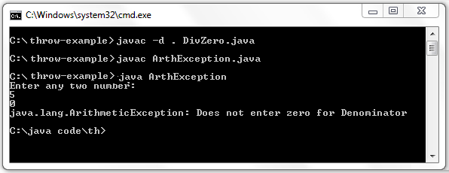

**Steps to Compile and Run code**

First you save throw-example files into you PC in any where, here i will save this file in C:\>

* C:\throw-example\>javac -d . DivZero.java
* C:\throw-example\>javac ArthException.java

**Note:**First compile DivZero.java code then compile ArthException.java code.